**Duke HR Service System**

|  |
| --- |
| A Project Report Presented to  CMPE-272  Fall, 2021 |
|  |

|  |
| --- |
| By |
| Sakshi Jain  Sarinder Virk  Serdar Demirci  Ashika Anand Babu  Date: December 2, 2021 |
|  |

|  |
| --- |
| Copyright © 2021 |
| Sakshi Jain, Sarinder virk, Serdar Demirci, Ashika Anand Babu |
| ALL RIGHTS RESERVED |

**ABSTRACT**

**Duke HR Service System**

By Sakshi Jain, Sarinder virk, Serdar Demirci, Ashika Anand Babu

A cross platform web application that is a Human Resource Management System. Our main objective is to build a role based single application that can be used for tracking employee payroll, timesheet and organization flow. We are concentrating on three main roles: Employee, Manager and HR Manager.

**Acknowledgements**

**Table of Contents**

**Chapter 1 Introduction**

* 1. Project goals and objectives
  2. Problem and motivation
  3. Project application and impact
  4. Project results and deliverables
  5. Market research
  6. Project report structure

**Chapter 2 Project Background and Related Work**

* 1. Background and used technologies

2.2 State-of-the-art technologies

* 1. Literature survey

**Chapter 3 System Requirements and Analysis**

3.1 Domain and business requirements

3.2 Customer-oriented requirements

3.3 System function requirements

3.4 System behavior requirements

3.5 System performance and non-functional requirements

3.6 System context and interface requirements

3.7 Technology and resource requirements

**Chapter 4 System Design**

4.1. System architecture design

4.2. System data and database design *(for software project only)*

4.3. System interface and connectivity design

* 1. System user interface design *(for software project only)*
  2. System component API and logic design *(for software project only)*

4.6 System design problems, solutions, and patterns

**Chapter 5 System Implementation**

5.1. System implementation summary

5.2. System implementation issues and resolutions

5.3. Used technologies and tools

**Chapter 6 System Testing and Experiment**

6.1 Testing and experiment scope

6.2 Testing and experiment approaches

6.3. Testing report (or case study results)

**Chapter 7 Conclusion and Future Work**

7.1 Project summary

7.2 Future work

**ReferencesList of Figures**

Figure 1. Architecture Diagram

Figure 2. Sequence Diagram

Figure 3. UML Diagram

**List of Tables**

Table 1. Role and It’s feature Page No. 10

Table 2. Functionalities Page No. 11

Table 3. System Data Page No. 15

1. **Introduction**
   1. **Project goals and objectives**Main goal of our system is to build a user friendly HR Service System, an easily usable/operable platform that can be administered with basic understanding of it’s working. Our HR Service system can be used by all three types of employees: HR Manager, Manager and an Employee.

Our platform can be used with just email ID sign in to access the

[Describe what are the goals and objectives of the project. In other words, what is your project? In addition, it covers the context in which the project is placed.]

* 1. **Problem and motivation**Often the common problem with HR systems is that the HR team has a different view and application compared to the employees. This comes at a cost.

HR systems are most of the time on-premise applications that are difficult to migrate and integrate with the cloud and add extra features.

Also, the systems are not user friendly. Employees are always keen on just getting the basic information such as tracking their timesheet and looking at their payroll in a single application rather than using 2-3 applications for the same data that are used to update and look at.

Our main goal was to integrate all the important features of an HR System into one application that can be accessed and updated by all types of employees and it must be easy to implement and add new features.

**1.3 Project application and impact**

Application

1. Integration of all the HR related features into a single application
2. Cloud based solution for smoother integration of new features
3. Role based access within the application

Impact on IT industry:

1. Faster and easy integration of new features
2. Easier to train employees for usage of application
3. Maintains security and privacy of the individual

**1.4 Project results and expected deliverables**

For Employees**:**

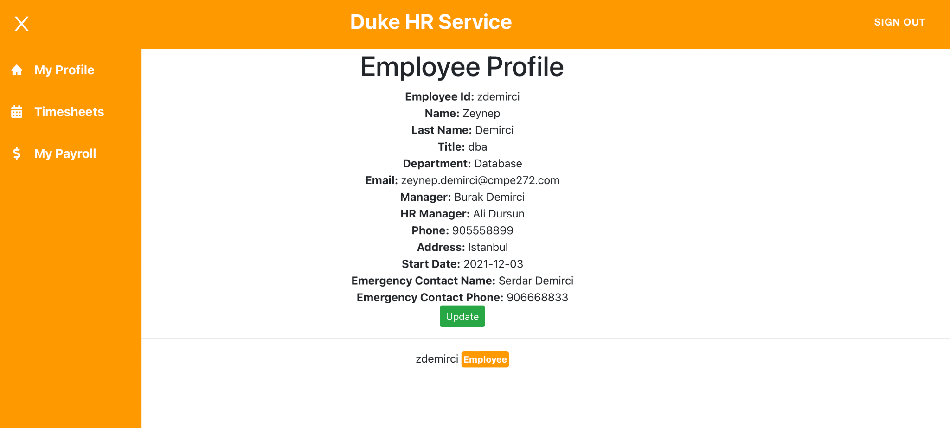

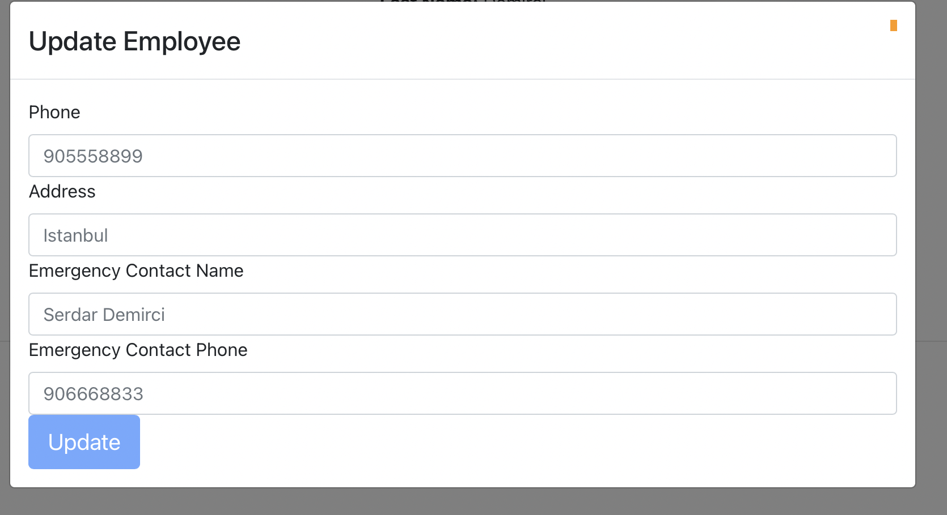

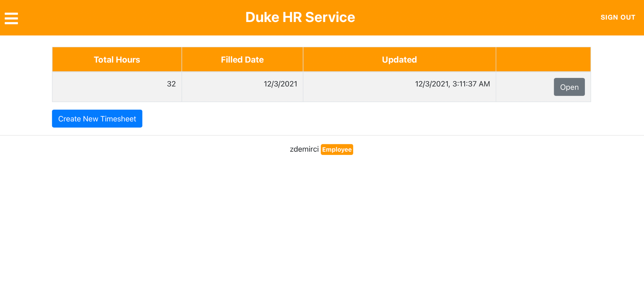

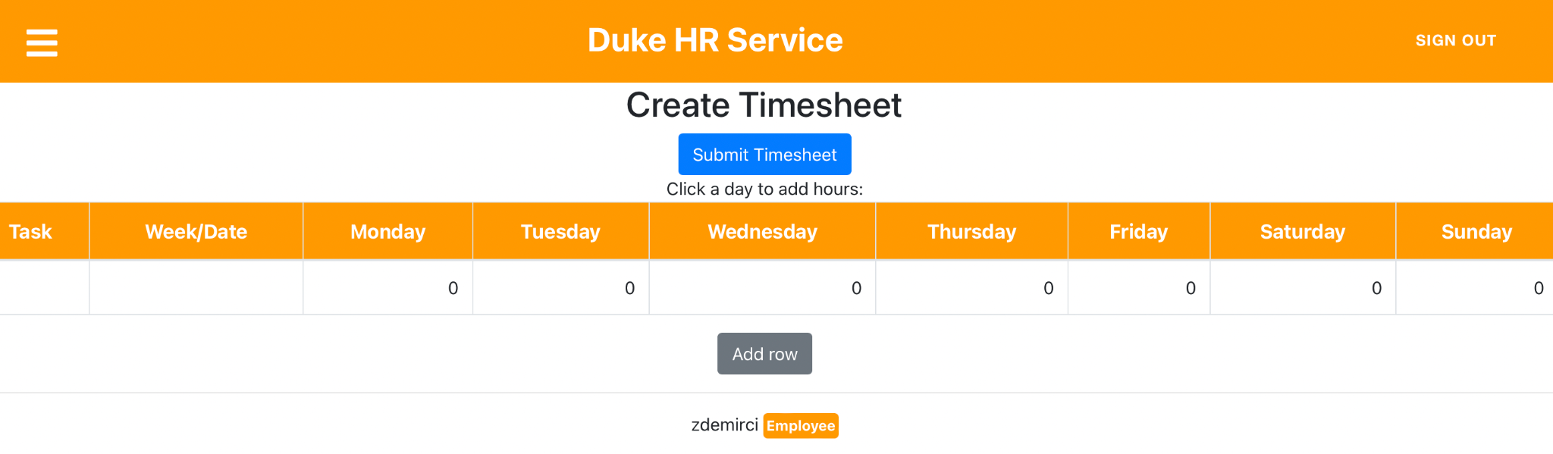

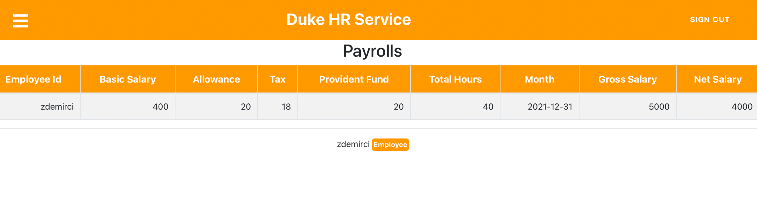

For Manager:

Extra features are:

List of employees:

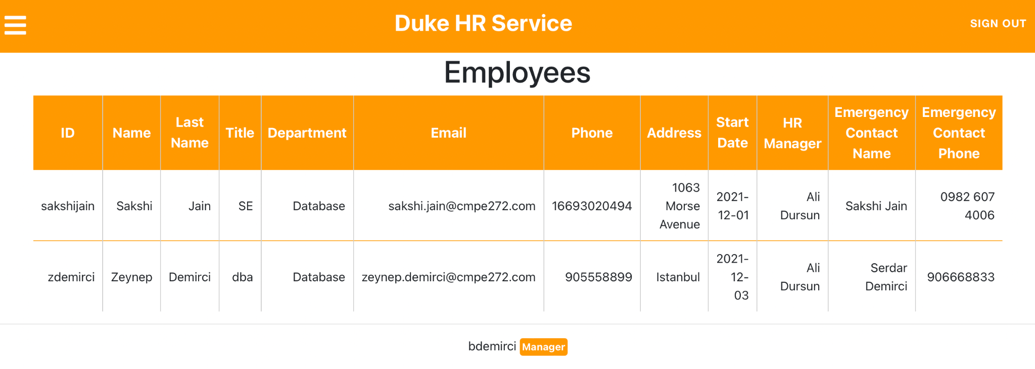

Employees Payroll:

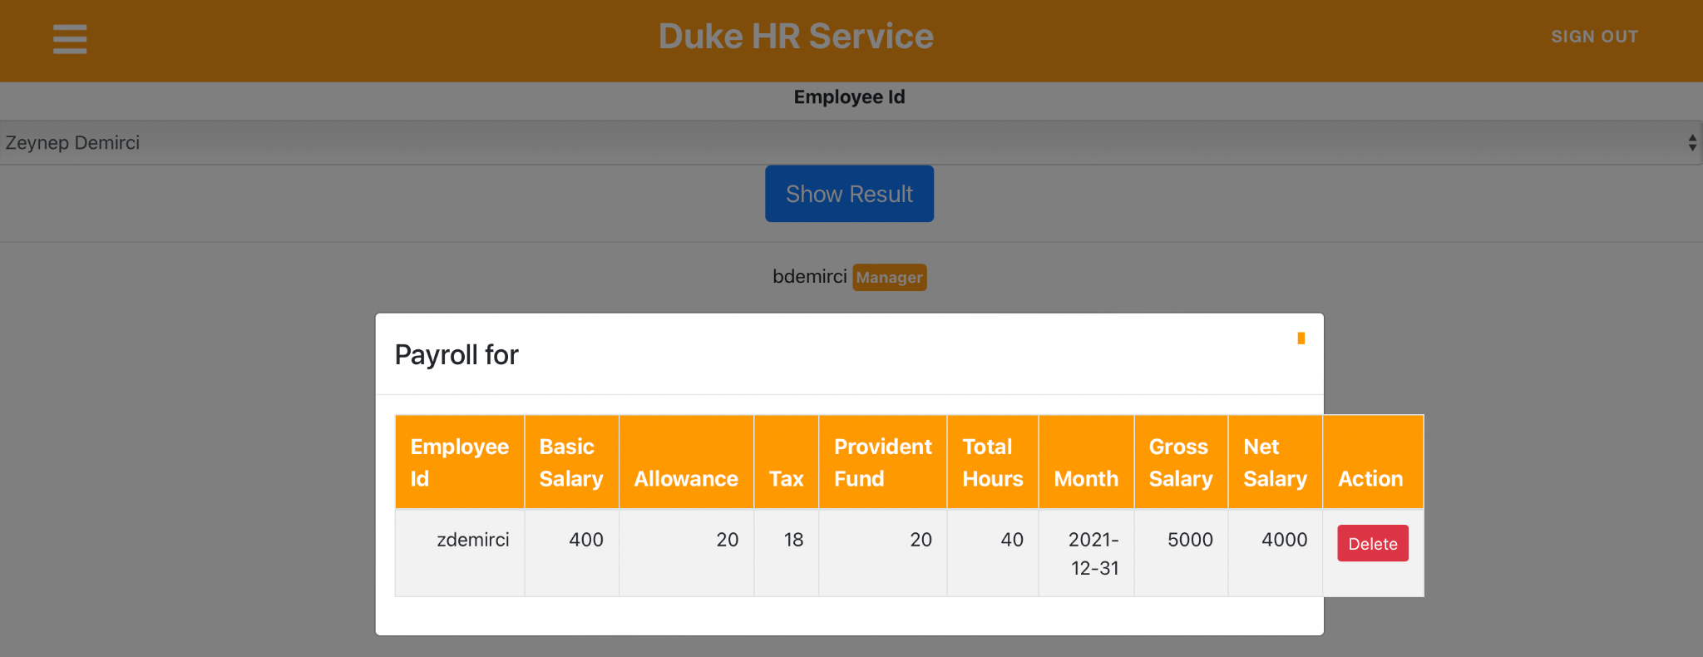

For HR Manager:

Extra features are Create rate:

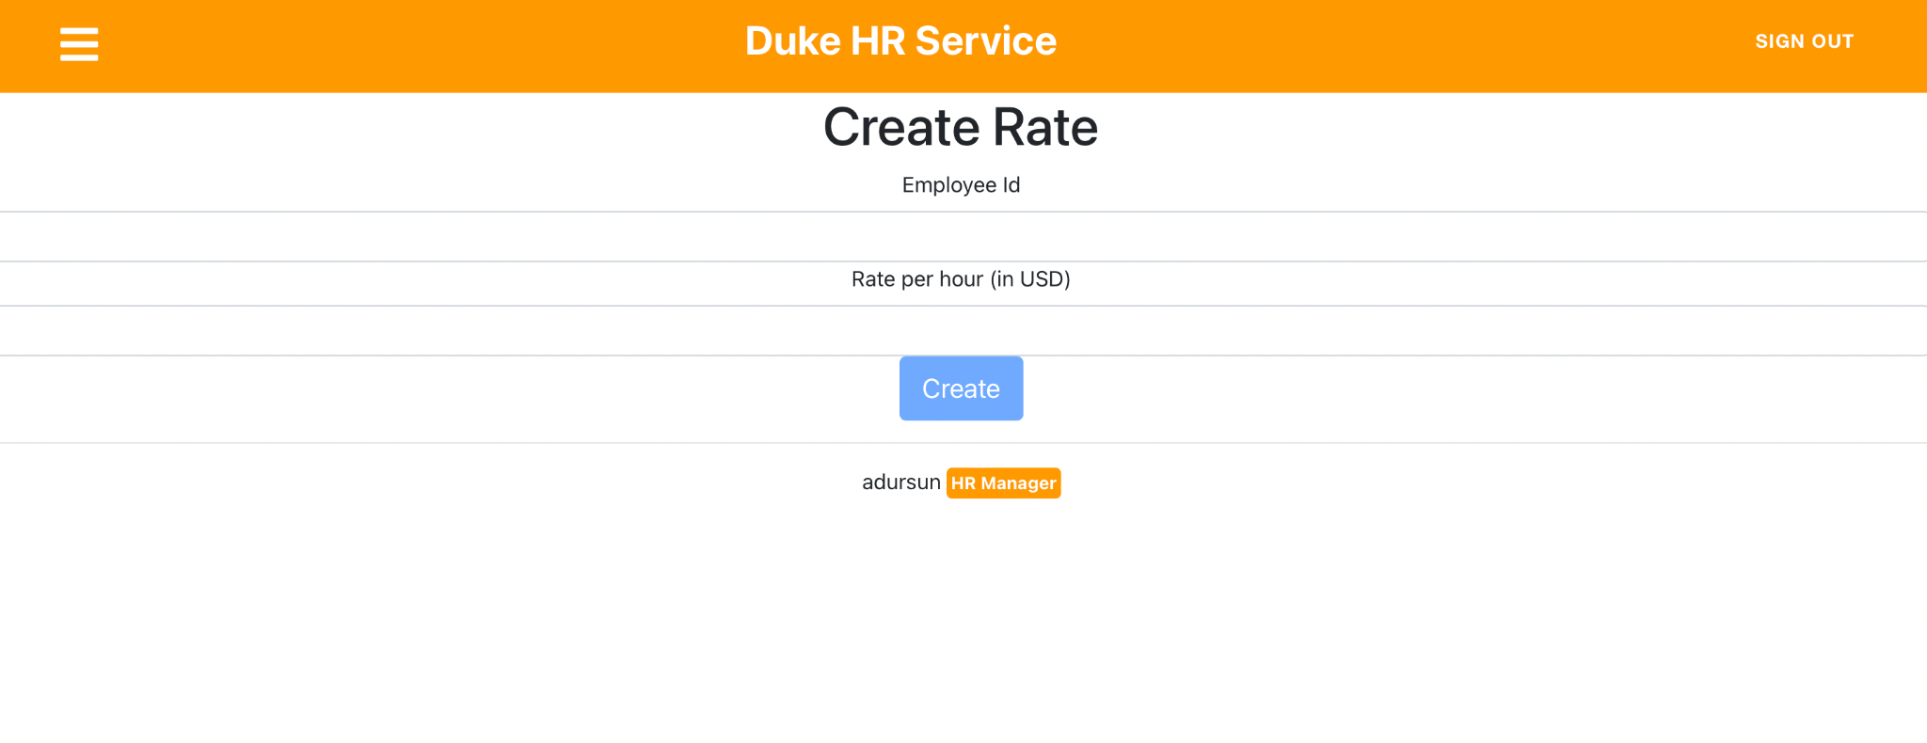

And Create Payroll:

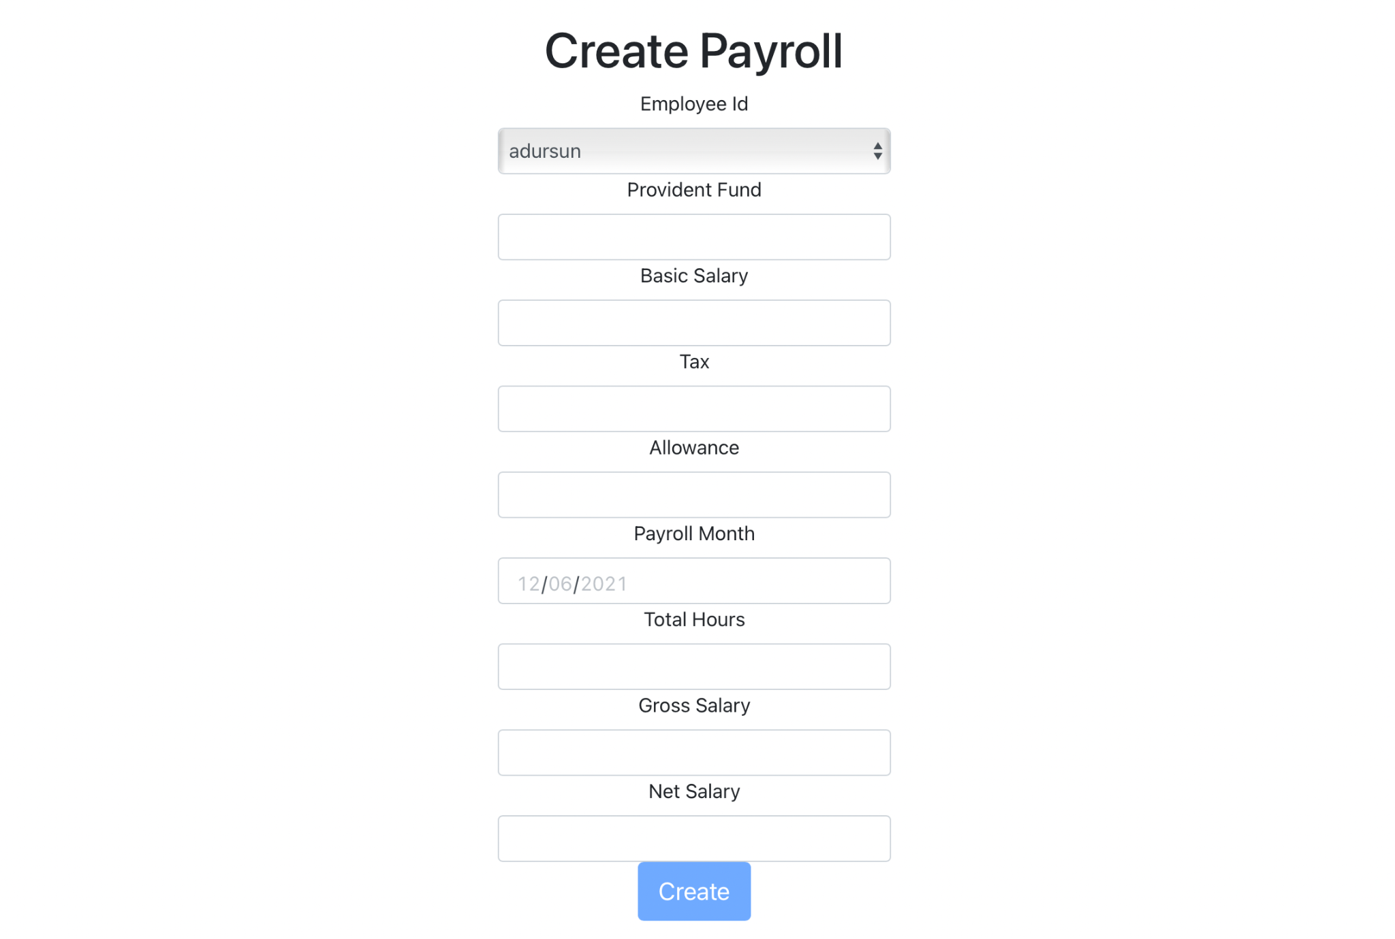

Github link for code: <https://github.com/sarinderv/cmpe272duke>

**1.5** **Market research**

We can see that the HRM system has a great future for investment and it is good to invest in this field currently.

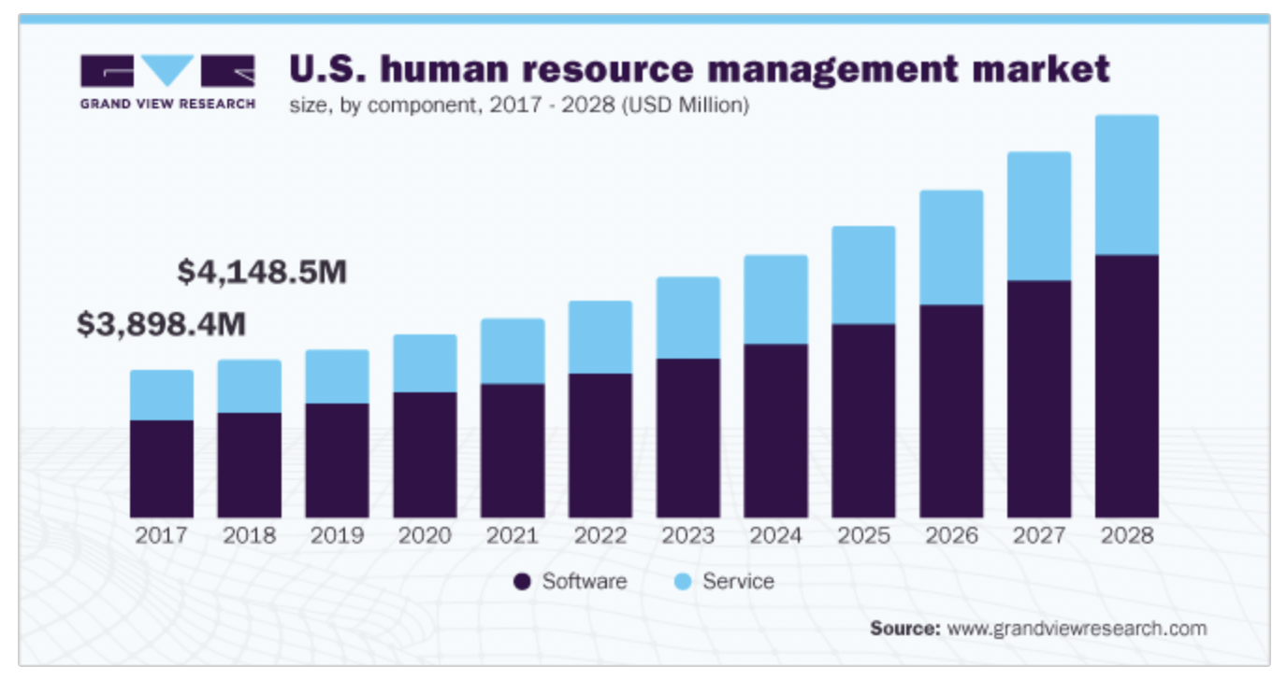

**1.6 Project report Structure**

Project report contains system requirements analysis, system design, implementation, testing and experiment.

**Chapter 2 Background and Related Work**

* 1. **Background and used technologies**

Technologies used:

1. Backend: DynamoDB
2. Frontend: Reactjs
3. Cloud Interface: AWS Amplify, Cognito and AppSync/GraphQL

We explored software engineering concepts related to our project and implemented it for getting a better understanding of it’s working.

Architecture of our Project:

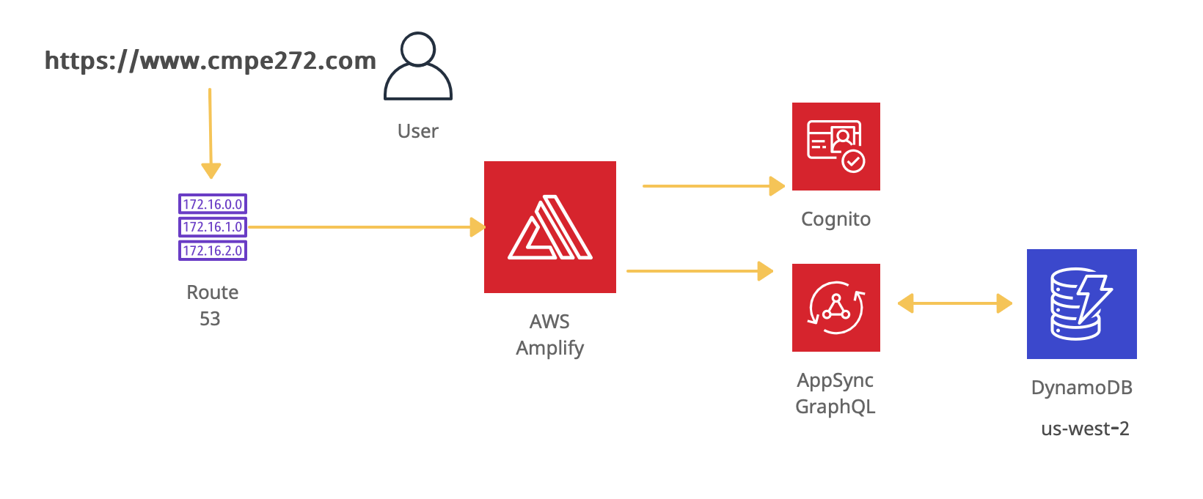

By implementing, we learnt state management and flow of data within the project and security layer offered by cognito on integration with Amplify.

* 1. **State-of-the-art**

Existing Products:

1. BambooHR offers small and growing companies a human resource information system (HRIS) that includes an applicant tracking system (ATS), time tracking, payroll processing, benefits administration, employee engagement and employee satisfaction tools, automated reminders, and workforce data analytics to manage all aspects of the employee lifecycle
2. Workday HCM is a cloud-based [human resource management software](https://searchhrsoftware.techtarget.com/definition/human-resource-management-HRM) system that unifies a wide range of HR functionality into a single system. The software provides benefits, talent management, payroll, time tracking, compensation, workforce planning and recruiting.

These products are currently most used. They also provide cross-platform applications i.e., app on both Android and ios

* 1. **Literature survey**

“We have data on 4,315 companies that use Workday Human Capital Management. The companies using Workday Human Capital Management are most often found in United States and in the Computer Software industry. Workday Human Capital Management is most often used by companies with 1000-5000 employees and >1000M dollars in revenue. Our data for Workday Human Capital Management usage goes back as far as 5 years and 4 months.”

From this report we understand that the market space for HRM Systems is huge and is always going to last.

**Chapter 3 System Requirements and Analysis**

**3.1.** **Domain and business Requirements**

Requirements:

For easier understanding, let us start with the UML diagram:

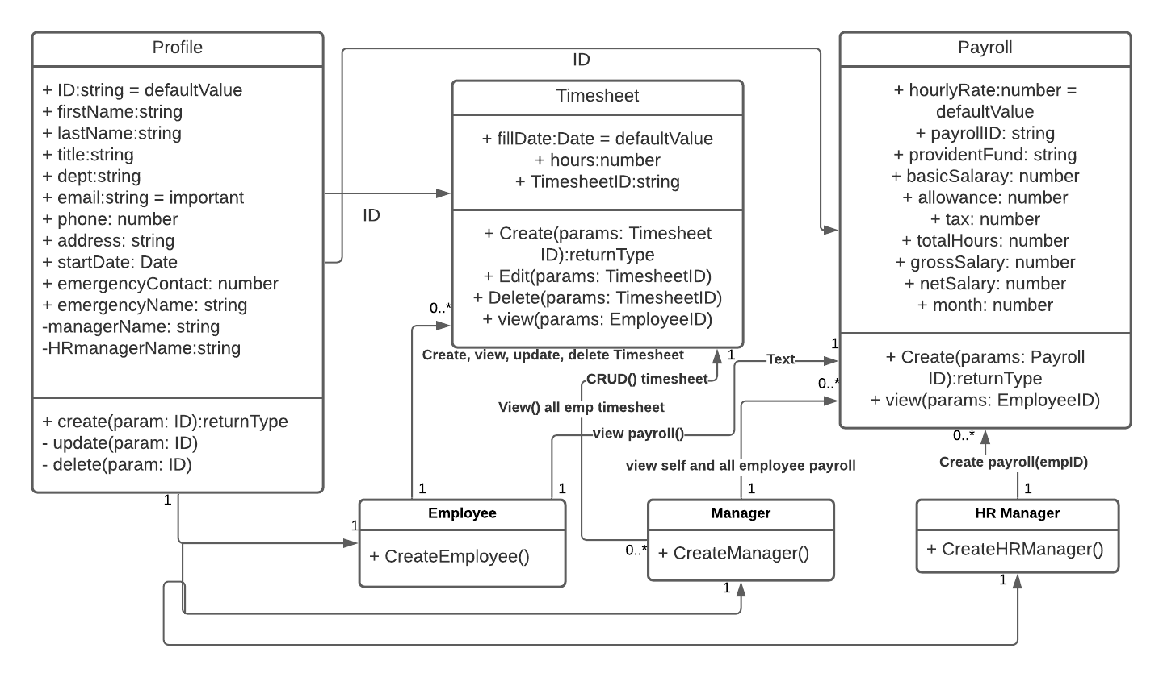

Here we can see that the three main classes are: Profile, Timesheet, Payroll

Profile has all employee details as parameters such as first name, last name, etc.,

CRUD operations can be performed on it.

Timesheet class is accessed when an employee creates a timesheet but it can also be viewed, deleted and updated

Payroll class has all information related to payment of salary of the employee. It is created by the HR manager and can be viewed by the manager and his employees.

The three main interfaces/roles are: Employee, Manager and HR Manager

Employee can neither create Payroll nor can he view payroll and profile of his team mates but a manager can view profile and payroll of his employees whereas an HR Manager can view profile and payroll and also create profile, rate of payment and payroll for an employee.

**3.2. Customer-oriented requirements**

To explain it from customer perspective, let’s look at the sequence diagram:

For Employee,

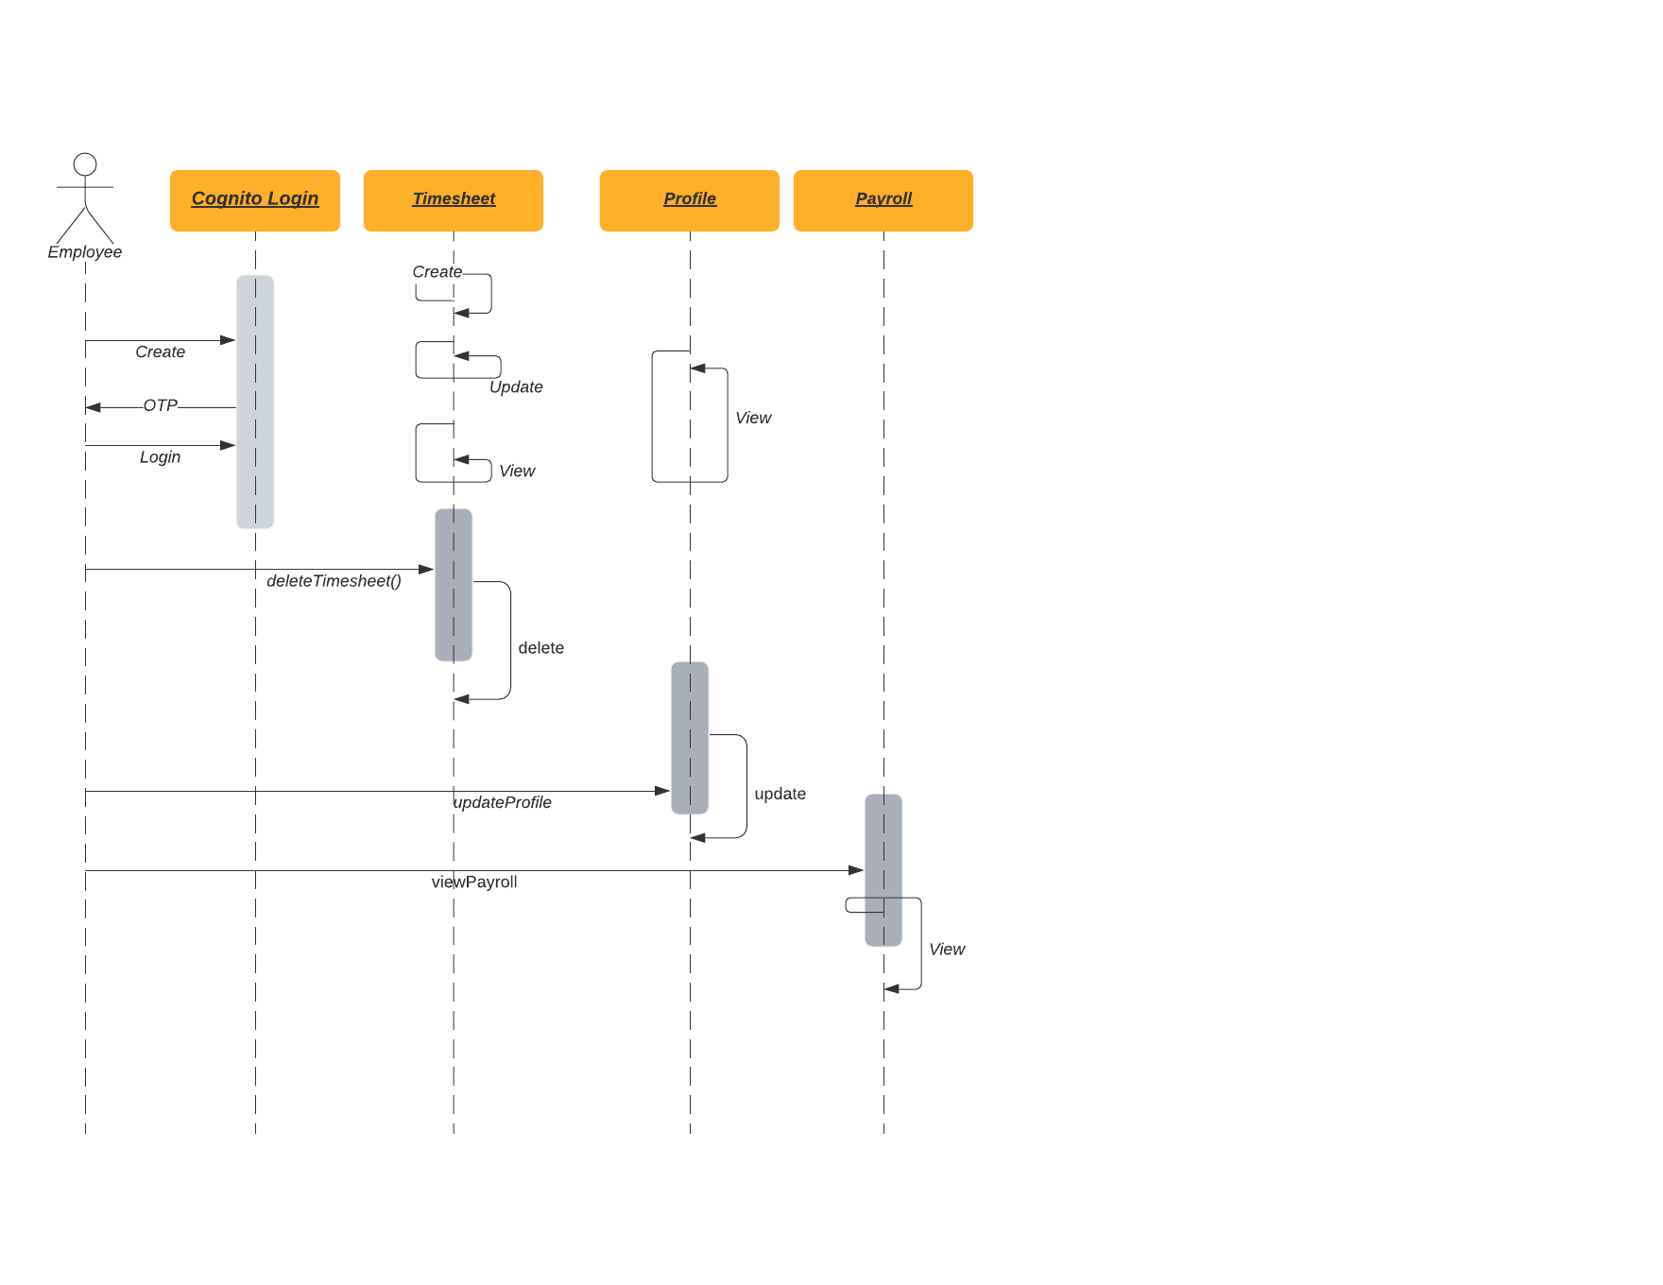

We can see that when an employee is logged in, he can CRUD on his timesheet, he can view and update his profile and can view his Payroll.

For Manager,

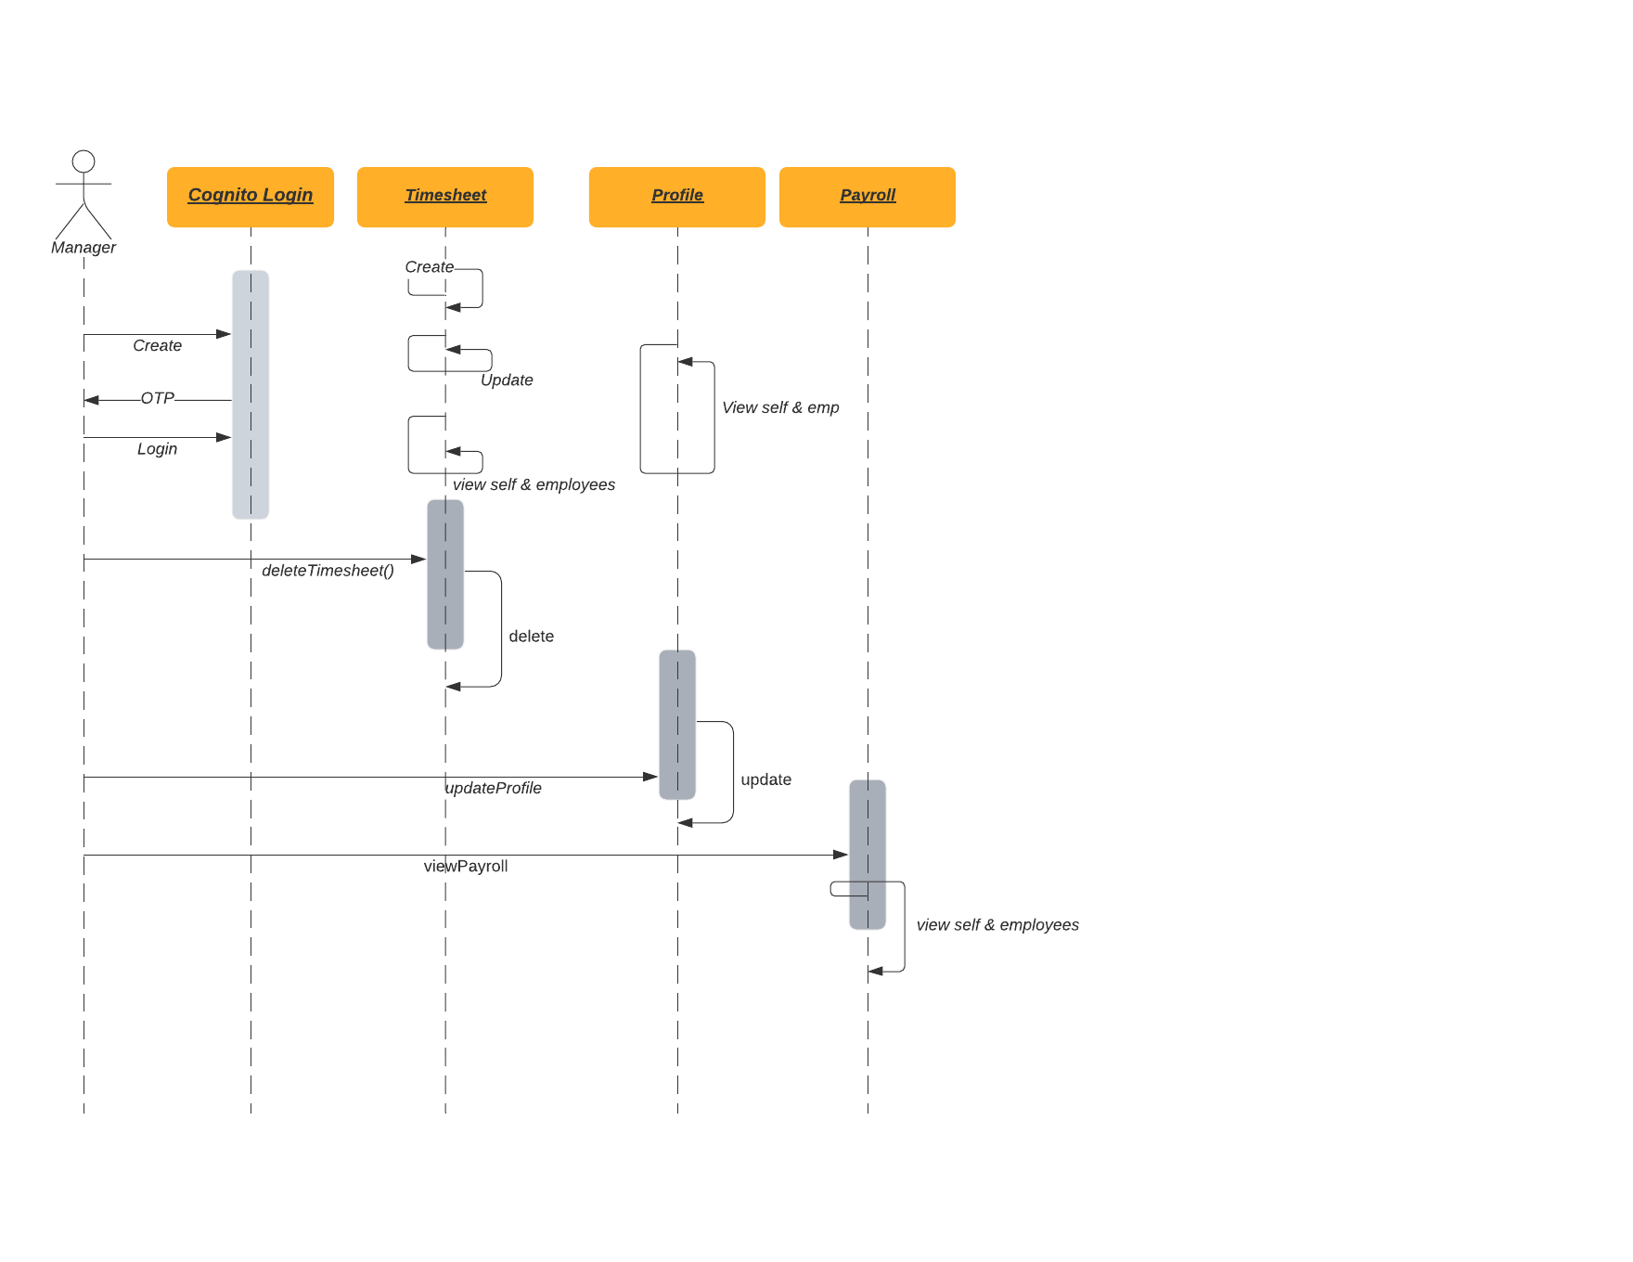

For Manager we provide the features of secure login, CRUD operations on his as well as his employees timesheet, view and update his and his employees profile, view his and his employees payroll.

For HR Manager,

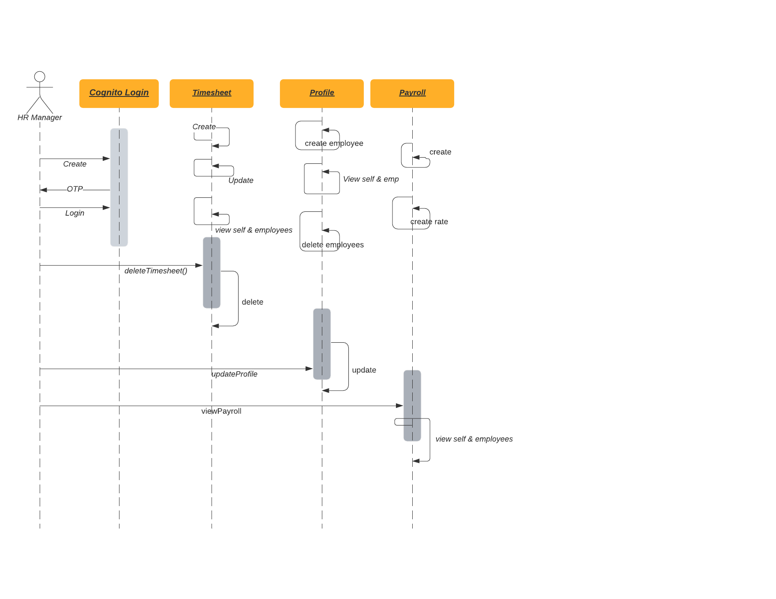

HR Manager can log in securely, CRUD on all employees profile, timesheet and create rate and payroll for all employees.

Table1: Role and It’s features

|  |  |  |
| --- | --- | --- |
| **Role** | **Features** | **Special Features** |
| Employee | CRUD Timesheet View and Update Profile View Payroll | - |
| Manager | CRUD Timesheet View and Update Profile View Payroll | Same features but also can be done on all employees under him |
| HR Manager | CRUD Timesheet View and Update Profile View Payroll on self and employees under him | Can also create employee, rate and payroll |

**3.3. System (or component) function requirements**

It is best to explain it in the table format for all the functionalities our application provide:

Table 2: Functionalities

|  |  |  |  |
| --- | --- | --- | --- |
| **Function** | **Input** | **Output** | **Behavior** |
| viewProfile() | employeeID | Loads details of Employee on the front end | This function is accessible by all roles |
| createProfile() | enter all details of employee in the form | Fill in employee details | This function is accessible by only HR Manager |
| updateProfile() | enter a error field or changes field in profile by updating in the for | View of updated information in profile section | This function is accessible by all and can be updated by themselves as it is easier for information tracking |
| deleteProfile() | employeeID | removes employee from accessing application | Accessible by only HR manager for removing an employee’s details |
| viewTimesheet() | employeeID and timesheetID | Loads timesheet of Employee on the front end | This function is accessible by all roles |
| createTimesheet() | weekly hours worked for every week | view filled details and use data for payroll | Accessible by all roles |
| updateTimesheet() | updated weekly hours value | view filled details and use data for payroll | Accessible by all roles |
| deleteTimesheet() | timesheetID and employeeID | details of timesheet not in view | Accessible by all roles |
| viewPayroll() | employeeID | view payroll of the person | Accessible by all roles |
| createPayroll() | employeeID | create payroll for employee based on his role and rate of payment | Accessible by only HR Manager |
| createRate() | employeeID | creates rate of payment per hour for each employee | Accessible by only HR Manager |

**3.4. System performance and non-function requirements**

Security is achieved by using Cognito functionality provided by AWS.

We are able to create groups and add employees to different pools based on their profile i.e., HR Manager is added to the HR Manager pool which behaves similar to Admin.

Only when the employee is added to the pool, he can make use of functionalities that are part of the organisation else it the application will display as ‘Employee not found’

Cognito Login:

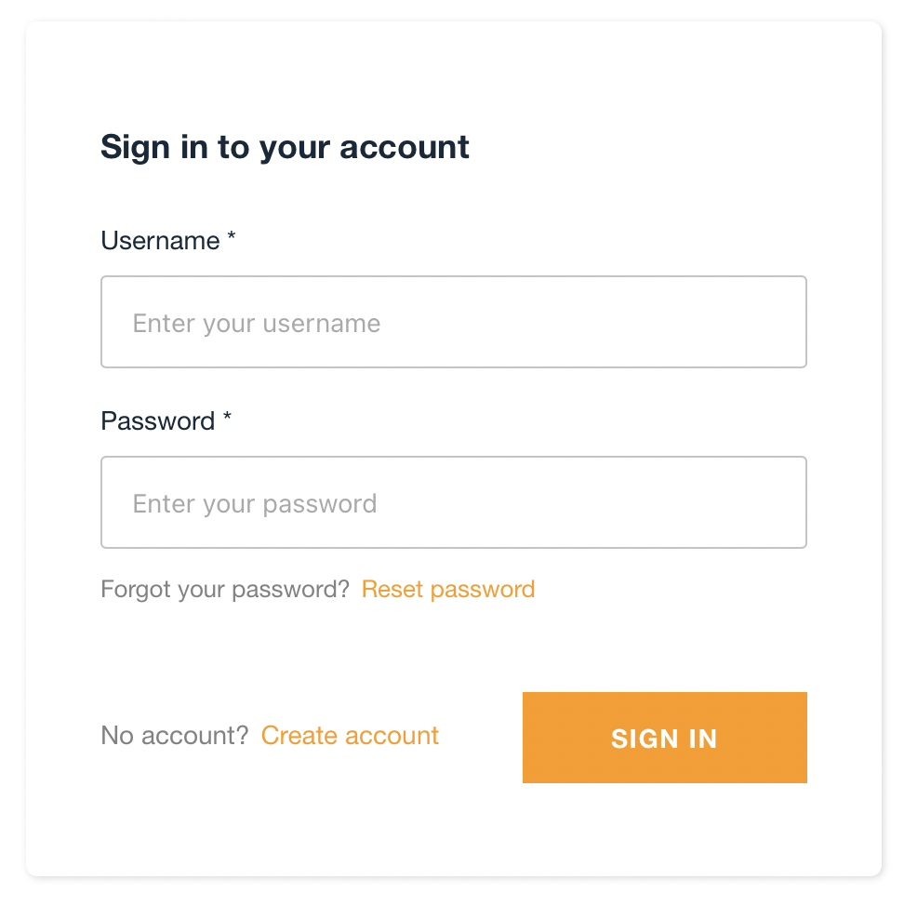

If the employee is not added to the pool:

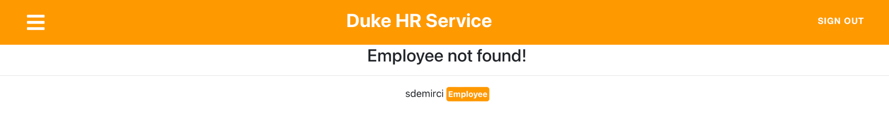

* 1. **System behavior requirements**
* The HR Manager creates the employee.
* The Employee lists and updates the profile.
* The Employee lists, adds, deletes timesheets.
* The HR Manager creates and lists payroll.
* The Employee lists the payrolls
* The Manager lists payrolls, timesheets ana employees
* The HR Manager lists timesheets and employees.
* The HR Manager updates the employee and deletes the employee.

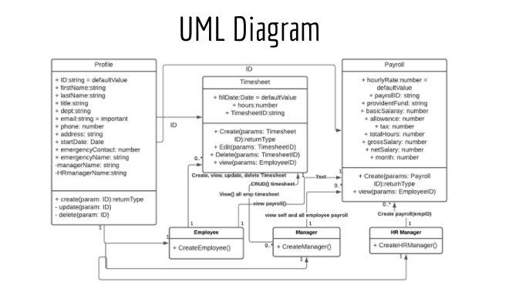

* 1. **Context and interface requirements**

Development Environment:

Visual Studio Code + Node.js + npm + AWS Amplify

Preliminary UI:

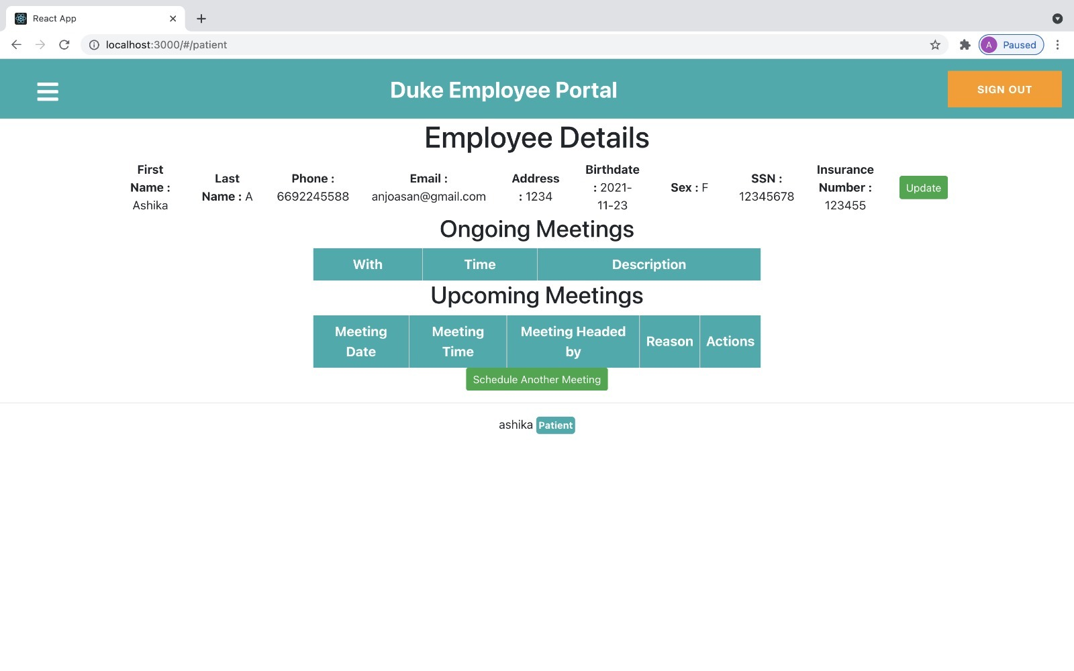

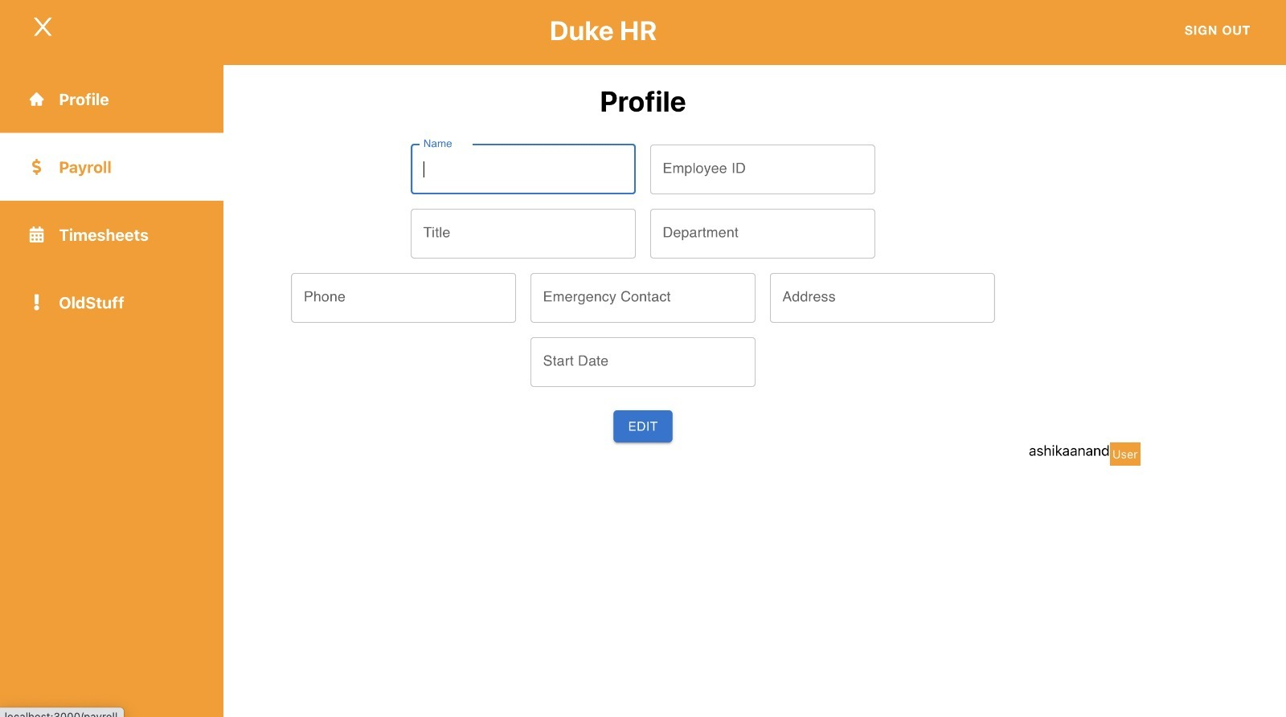

Our design plan on paper:

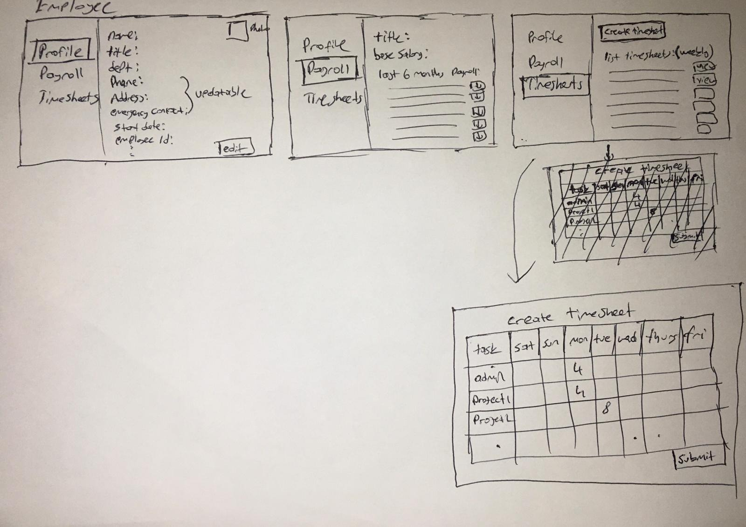



From this we analysed that meeting features will have to be integrated with physical sensors for the number of rooms per floor, per building and company to track availability. So we went ahead with features such as timesheet, payroll and profile details.

* 1. **Technology and resource requirements**

Technologies used: Javascript based React.js and Node.js. NoSQL Database DynamoDB and cognito for security with AWS Amplify for all data management.

Resources: Role based dataset for tracking and understanding flow of UI and its working on the backend

**Chapter 4 System Design**

The three core tenets followed in designing the system are scalability, reliability, and availability. This is accomplished at the database layer with the use of DynamoDB, at the service layer through the use of a serverless-architecture and AWS AppSync, and at the UI layer through the use of a global DNS, AWS Route53 and CDN AWS CloudFront. Each of these are AWS cloud-native technologies that meet the scalability requirements while also not having any single point of failure. For example, the GraphQL API’s utilize AWS Lambda to communicate with the DynamoDB data layer. AWS Lambda scales out automatically and without any intervention required. The same is true of DynamoDB.

Also, at the system management level, the system design strives for scalability. For example, the use of Cognito and RBAC group-based permissions allows just one system administrator to easily perform account management for dozens or hundreds of users.

**4.1 System architecture design**

Our Software Architecture:



On hitting the web address <https://www.cmpe272.com> cognito login page can be accessed. On login securely through AWS Amplify with the help of cognito we can access all the features provided by the application.

* 1. **System data and database design** *(for software project only)*

Table3: System Data

|  |  |
| --- | --- |
| **Parameters** | **Type** |
| firstName | string |
| lasName | string |
| email | email |
| employeeID | string |
| phoneNo | number |
| title | string |
| Address | string |
| startDate | date |
| emergencyPhoneNo | number |
| emergencyName | string |
| HRManagerName | string |
| ManagerName | string |
| fillDate | date |
| hours | number |
| timesheetID | string |
| hourlyRate | number |
| payrollID | string |
| providentFund | string |
| basicSalary | number |
| allowance | number |
| tax | number |
| totalHours | number |
| grossSalary | number |
| netSalary | number |
| month | number |

In the UML we can see what features are associated with which class. They are also mapped the same way in the database.

* 1. **System interface and connectivity design**

External interface:

AppSync and GraphQL:

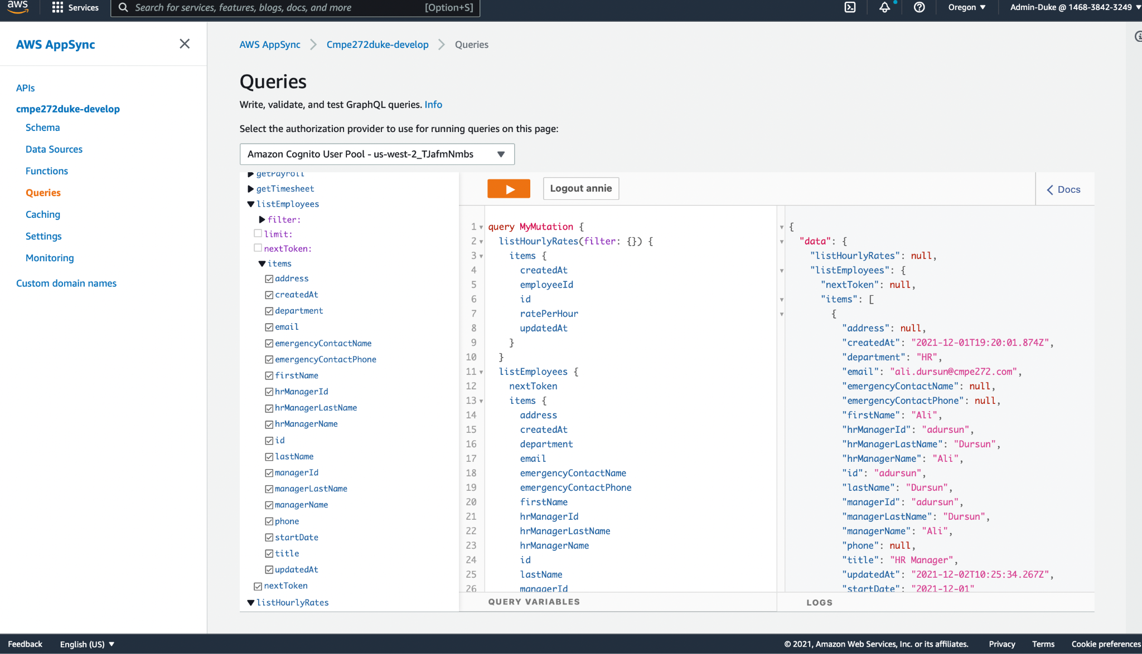

Used GraphQL in AppSync for testing the working of apis and running and testing queries

* 1. **System user interface design** *(for software project only)*

in this section we present the general system-and-user interface design and flow.

4.4.1 **Navigation-based UI**

The left side of the UI contains a “left-navigation menu” which allows the UI to flow through the different screens. The left-navigation menu paradigm is common throughout web applications and is intuitive, thereby reducing the amount of training required.

4.4.2 **Role-based UI**

Several sections of the UI are visible to all users all the time, while some other specific sections are only visible to those with a specific role. For example, in the following screenshot, the “My Profile”, “Timesheets”, and “My Payroll” left-navigation sections (outlined in blue) are visible to all users, whereas “Payroll” and “Employees” sections (outlined in red) are only visible to users with the “Manager” role:

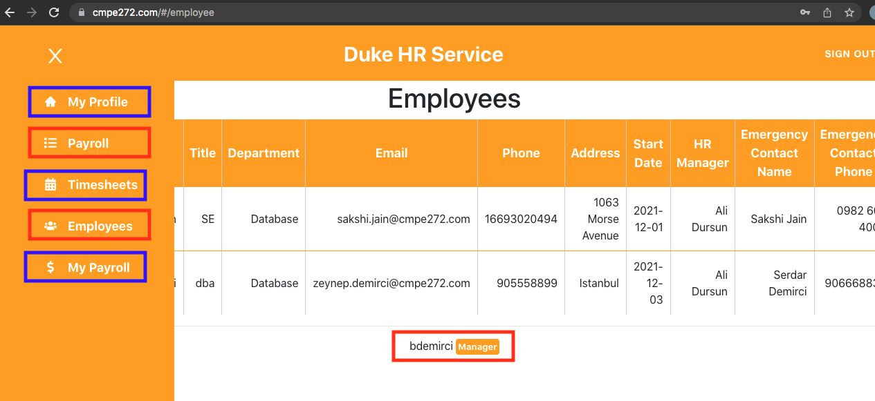

This is a common UI pattern in Enterprise applications that allows the UI to easily adapt to the various degrees of authorization available to different roles.

* 1. **System component API and logic design***(for software project only)*

[Present software component API and logic design. This section must include textual description accompanied with diagrams]

* 1. **Design problems, solutions, and patterns**

For the current project we understood that Employee and Manager are not enough for roles. Who creates payroll? We are all aware that it is not Manger. Who creates an employee? Again it is not manager and hence added the HR Manager role who creates employees and his payroll.

The only trade off we had to do was spend more time on the project.

As a development environment, at first it was difficult to get rid of old practised habits of SQL based thinking when it comes to data but we later picked on JSON and found it to be smoother to use than traditional SQL style.

**Chapter 5 System Implementation**

**5.1. System implementation summary**

Application is completely implemented. All the features are working as per the requirements we had planned to add. We were also able to add a secure layer thanks to Cognito that comes with AWS Amplify.

**5.2. System implementation issues and resolutions**

During implementation of the project, there were few issues we faced.

1. To go traditional MERN stack or Java based application design decisions or use Cloud and learn entirely new concepts and technologies. We chose the latter as we realised the ease of implementation with AWS Amplify. Secure services can be up and running in hours.
2. Timesheet: we have all used one and are sure that we always fill in the date and hours of work performed for every day of the week. How to handle such diverse data? So we converted week data into string before which we summed it up and tracked it in weekly hours

**5.3. Used technologies and tools**

Software tools used were: Interface of AppSync and DynamoDB for testing database by querying and API working by sending parameters that an API requires. AppSync also let’s us choose expected parameters in output on querying.

We have also used LucidChart and creately for plotting architecture, UML and sequence diagrams for understanding application working **Chapter 6 System Testing and Experiment**

**6.1 Testing and experiment scope**

Our main testing consists of User testing of UI by creating expected on the paper v/s versions of arriving at the current UI and Querying on AppSync for testing api functions and DynamoDB for testing Database entries.

All APIs of every component were tested using AppSync:

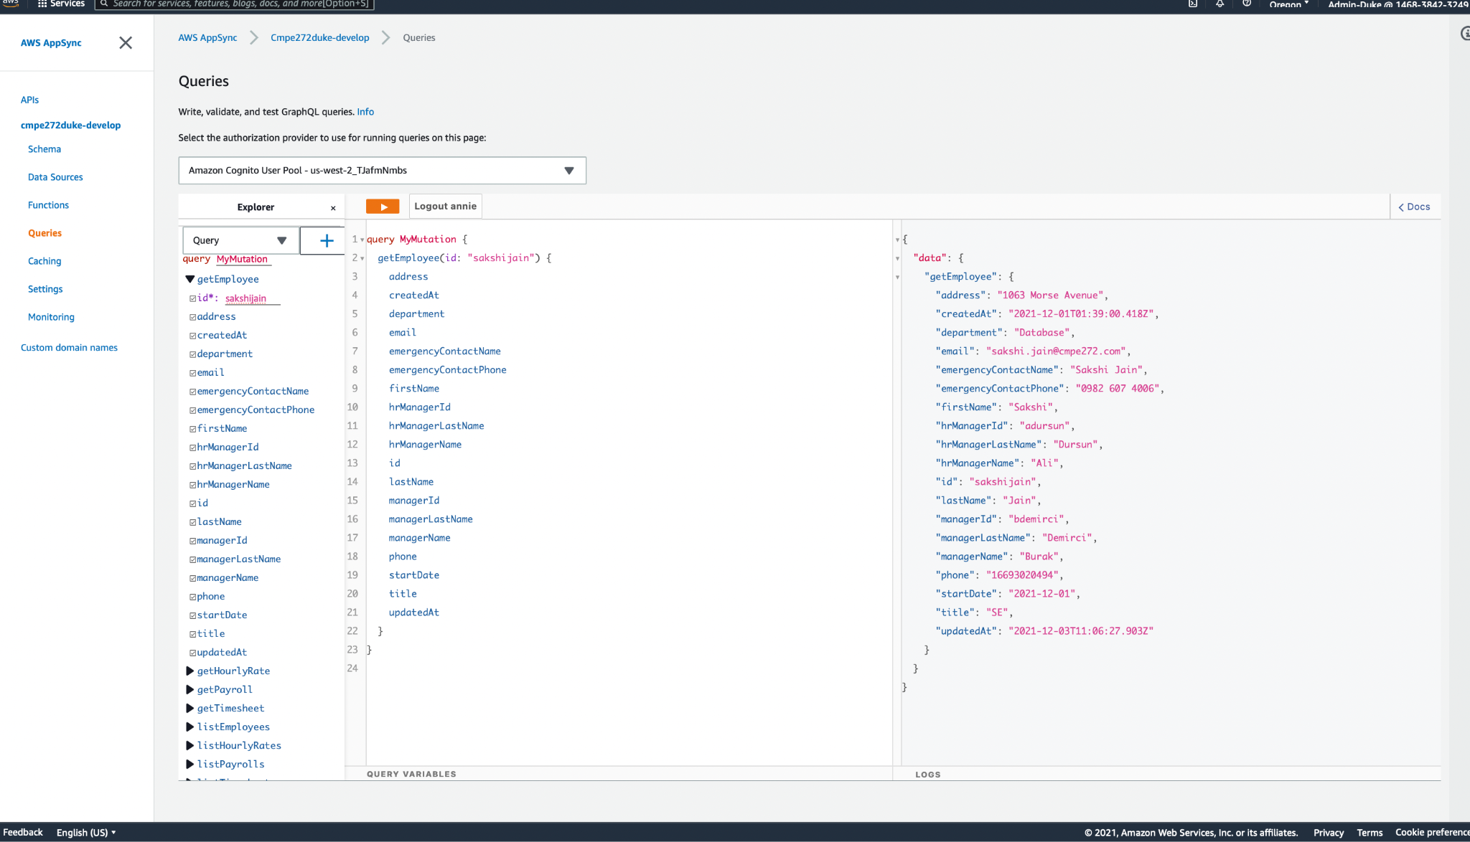

All table entries were tested using DynamoDB interface on AWS:

Employee Profile:

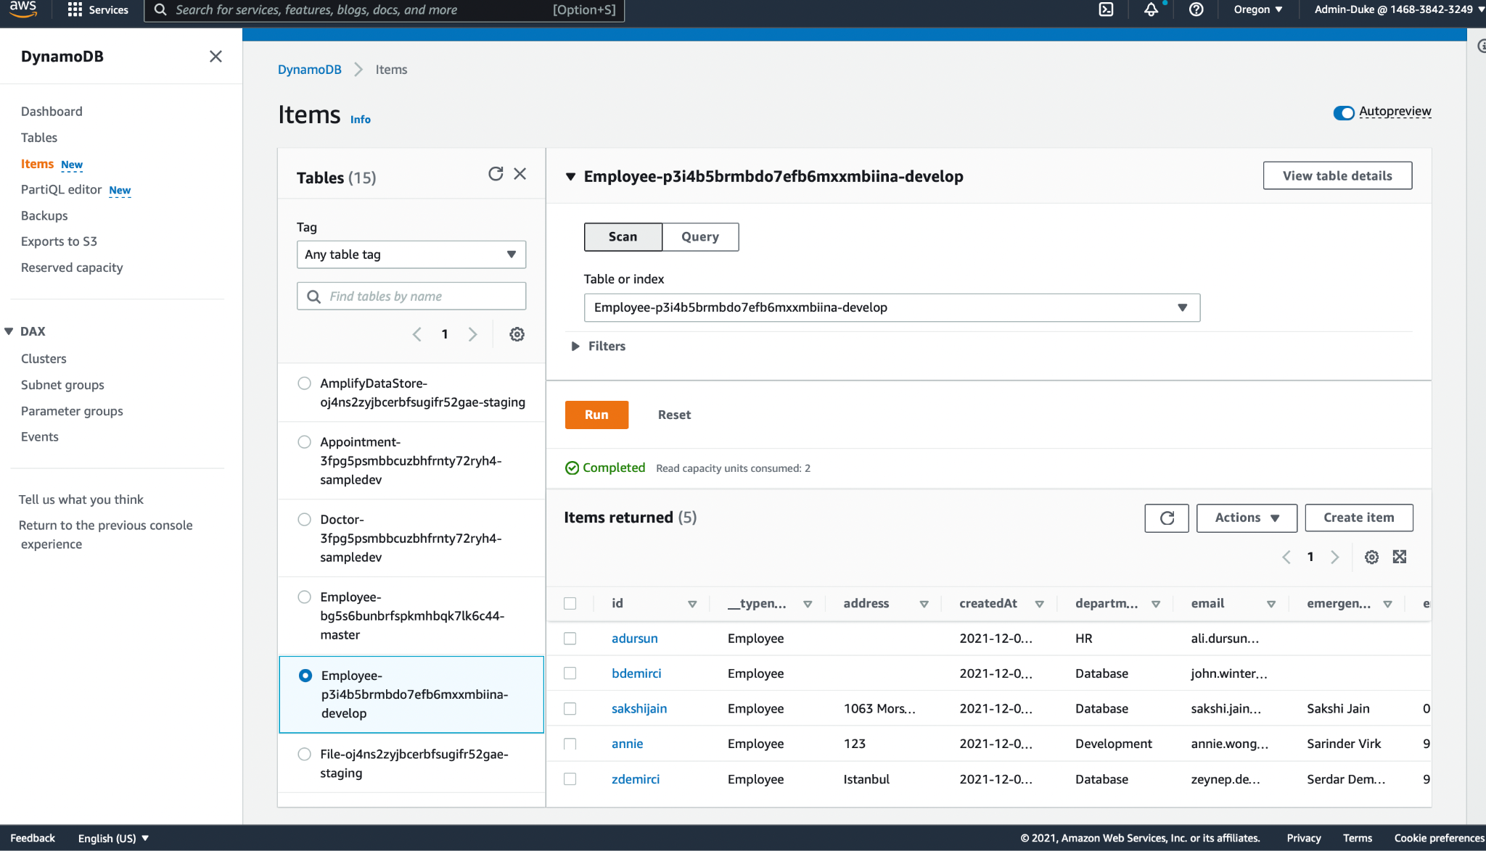

Payroll:

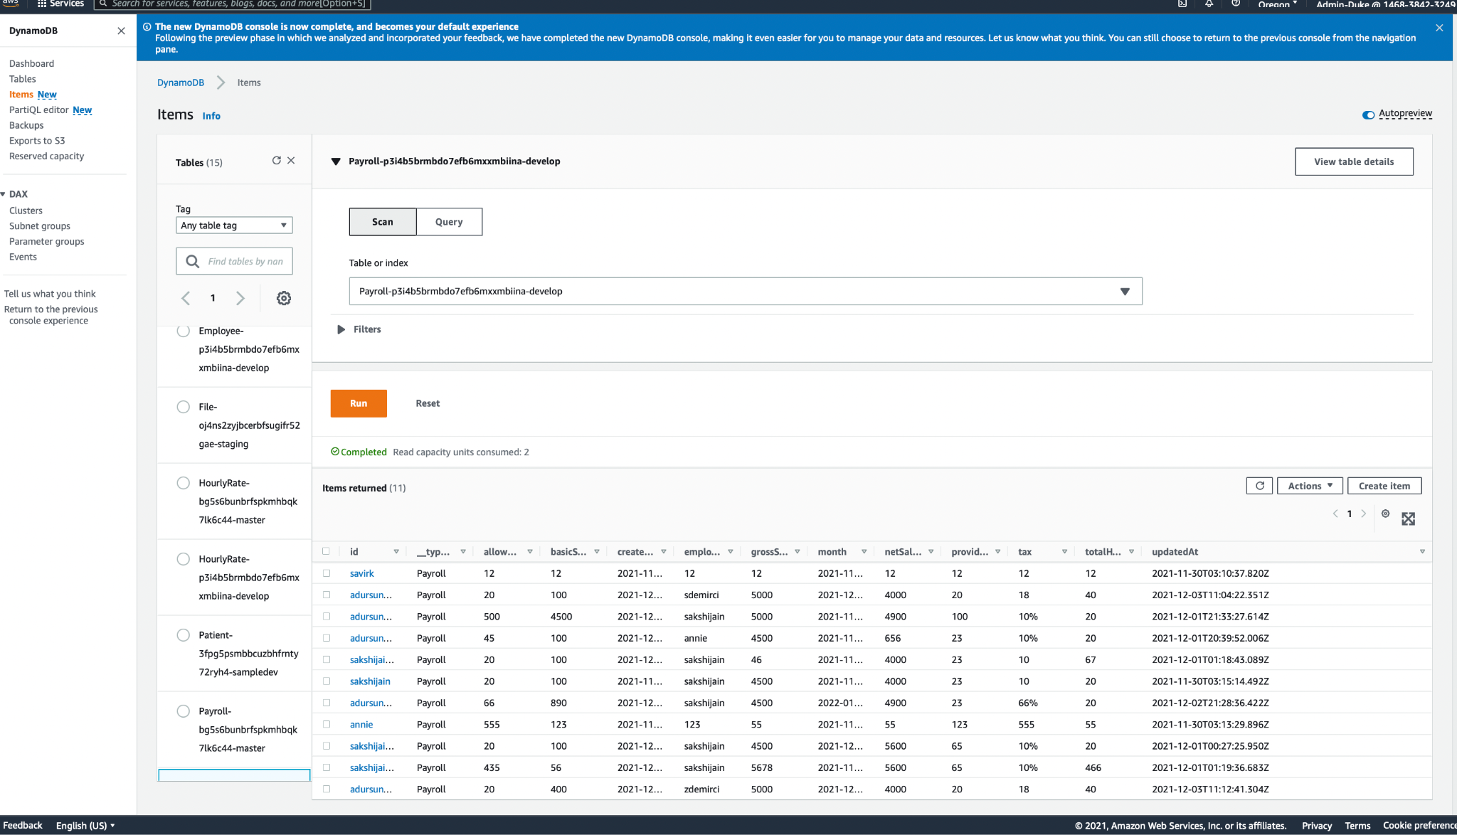

Timesheet:

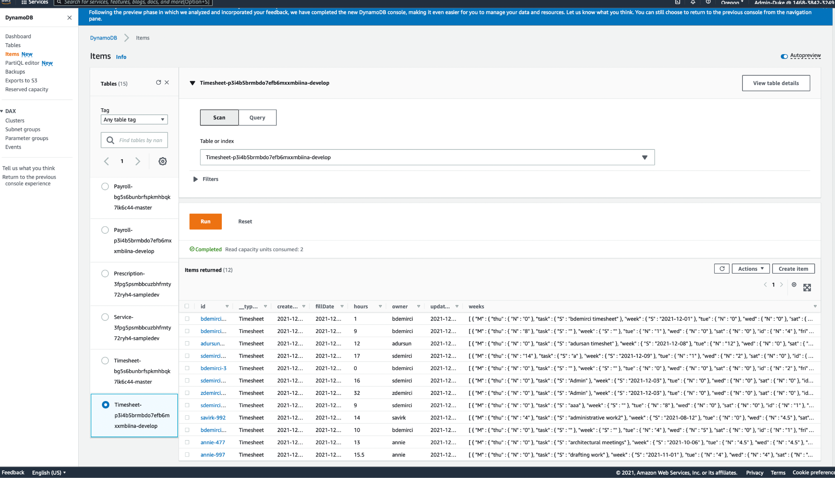

**6.2 Testing and experiment approaches**

Features were developed individually. Each individual performed unit usability testing and verified if the feature works perfectly on all roles. Then all the features were integrated one by one. On integration, every feature was exhaustively tested to ensure that nothing was affected on integration.Then we have implemented usability testing by extensively testing each and every feature of it’s working with mindset of user.

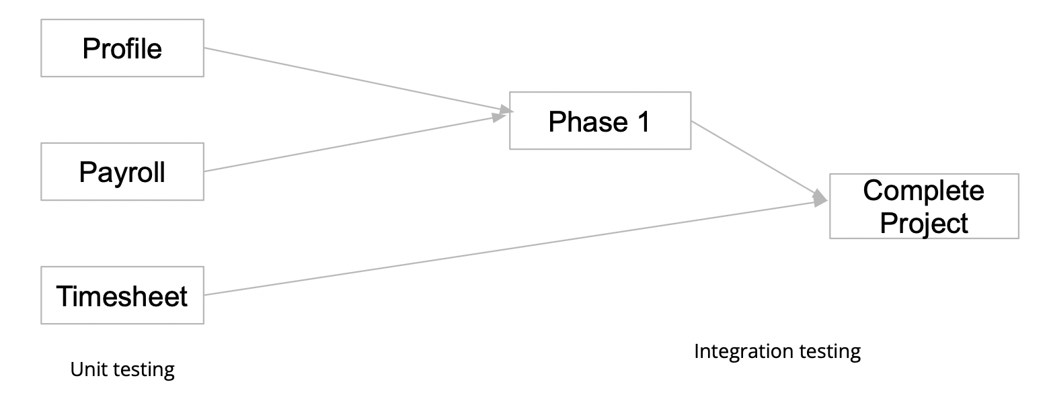

**6.3 Testing and experiment**

As it can be seen in the console, there are no errors or bugs

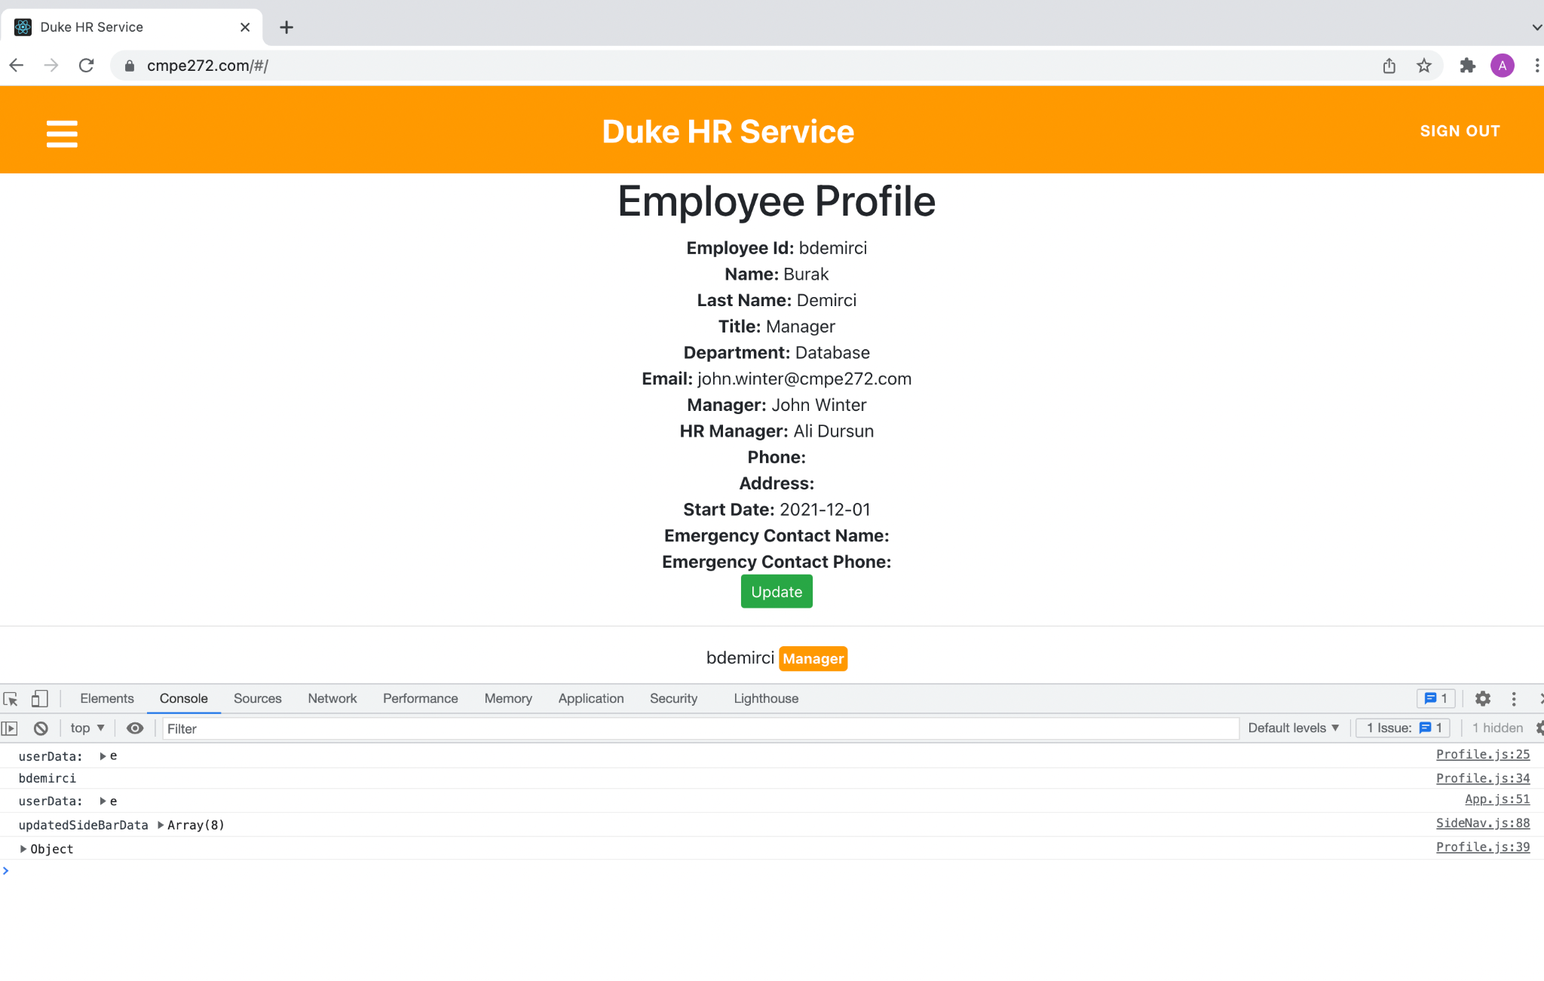But we do need to update our design at few instances for fitting the role based challenges such as:

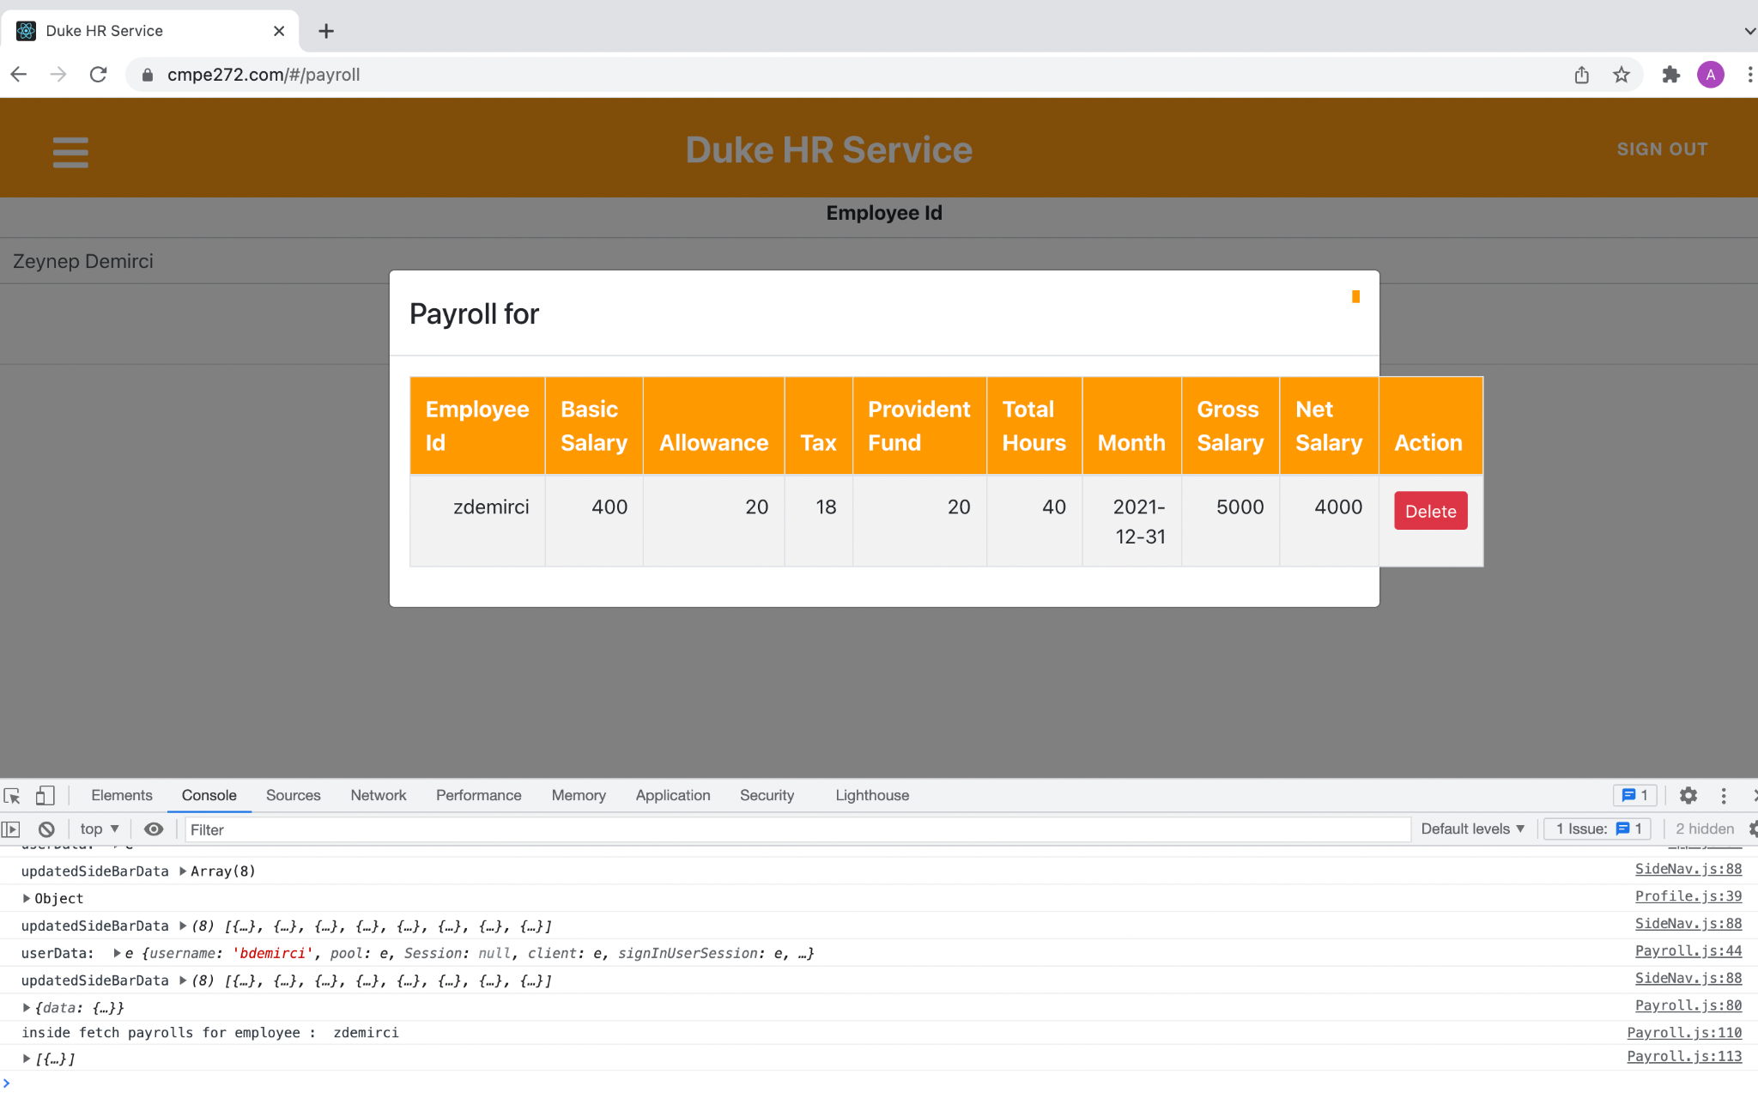

Delete action is only enabled for the manager and not employee and hence it will not appear andfit within the pop up UI but due to this extra feature, it has to be modified.**Chapter 7 Conclusion and Future Work**

**7.1 Project summary**

This project can be used as an example for developing a cost efficient solution that can be accessed securely by anyone in the company with appropriate UI related to their role. Our results have proved that there are no errors when dealing with role based access in a single application and also that all features can be accessed via the same platform rather than separating them into more than one platform. We have understood that our project is worth the effort and understanding for creating any role based application on cloud.

**7.2 Future work**

We would like to provide graphical representation of pay and add features such as increment by calculating length of service to the company, approval rating by teammates and manager, and a chat bot with HR services for any queries. We would also love to add a feature such as downloading payroll with s3 integration.

**References**

1. <https://www.softwareadvice.com/hr/bamboohr-profile/>

1. <https://searchhrsoftware.techtarget.com/feature/Workday-HCM-HR-tools-product-overview>

1. <https://enlyft.com/tech/products/workday-human-capital-management>